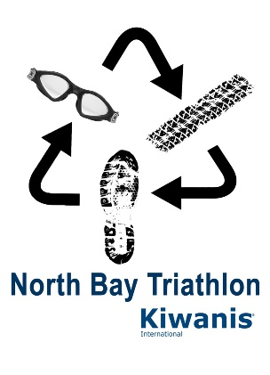
2023 Triathlon Schedule
FRIDAY, JUNE 30 T.G.I.F.!
Race Kit Pick-up  North Bay Canoe Club | Kid’s Race Kits | 5:00 p.m.– 6:00 p.m.
 | All others | 6:00 p.m. – 7:00 p.m.
SATURDAY, JULY 1 Happy Canada Day!
Race Kit Pick-up  North Bay Canoe Club | Kid’s Race Kits | 10:00 a.m. – 12:00 p.m.
 | All others | 4:00 p.m. – 5:00 p.m.
Kid’s Triathlon | Walkthrough Instructions | 12:30 p.m.
 | Kid’s Tri Starts | 1:00 p.m.
SUNDAY, JULY 2 Happy Race Day!
Race Kit Pick-up  North Bay Canoe Club | Try-a-Tri | 6:30 a.m. - 7:30 a.m.
 | Adult & Relay Teams | 6:30 a.m. - 9:00 a.m.
Try-a-Tri | Race Starts | 8:00 a.m.
 | Awards | 10:30 a.m.
Adult & Relay Teams | Race Starts | 9:30 a.m.
 | Wave 1 Duathlon
 | Wave 2 Women & Relay Teams
 | Wave 3 Men
Exhibition Water Polo  Armstrong Beach |  | 11:00 a.m.
 | Awards | 12:30 p.m.
Thank you for participating in this year’s Kiwanis North Bay Triathlon !

